

**Database Systems**

**Lab 05**

**Submitted By**

**Soha Ali**

**51169**

**Submitted To:**

**Ma’am Hafsah Mehmood**

**Task 1: Retrieve name, continent and region columns from the country table.**

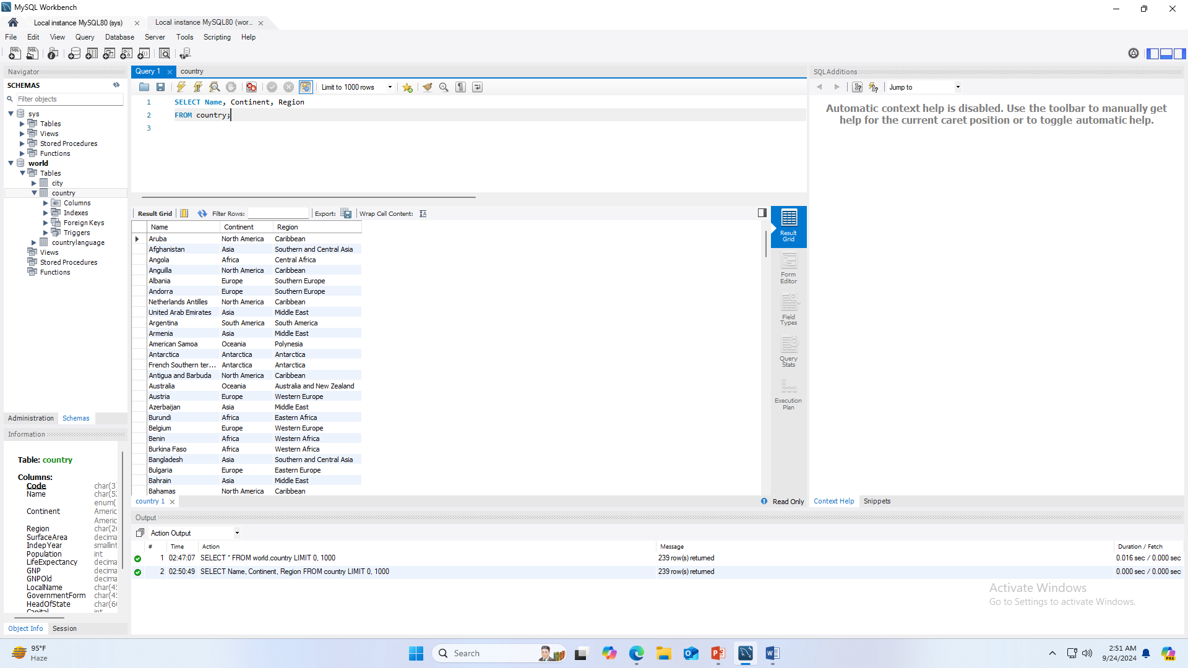

**Task 2: Retrieve all the countries whose name starts with the letter 'A'.**

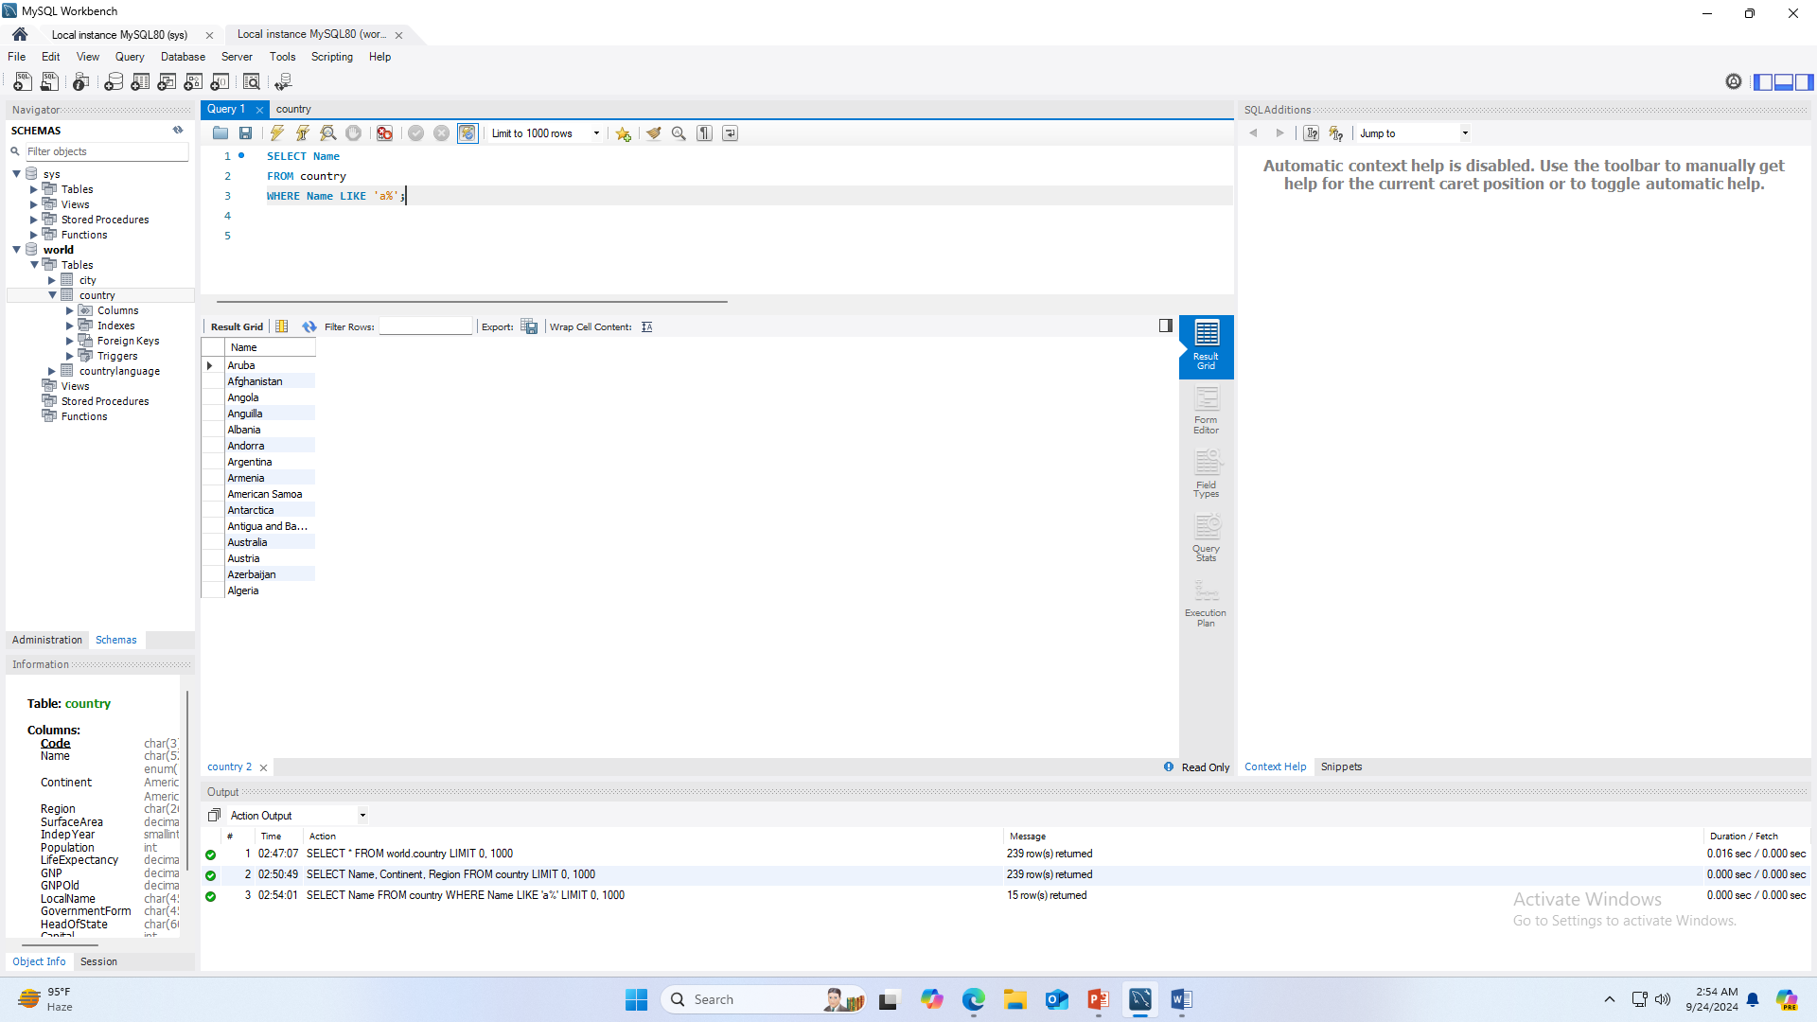

**Task 3: Retrieve all the countries that fall under Asia Continent'.**

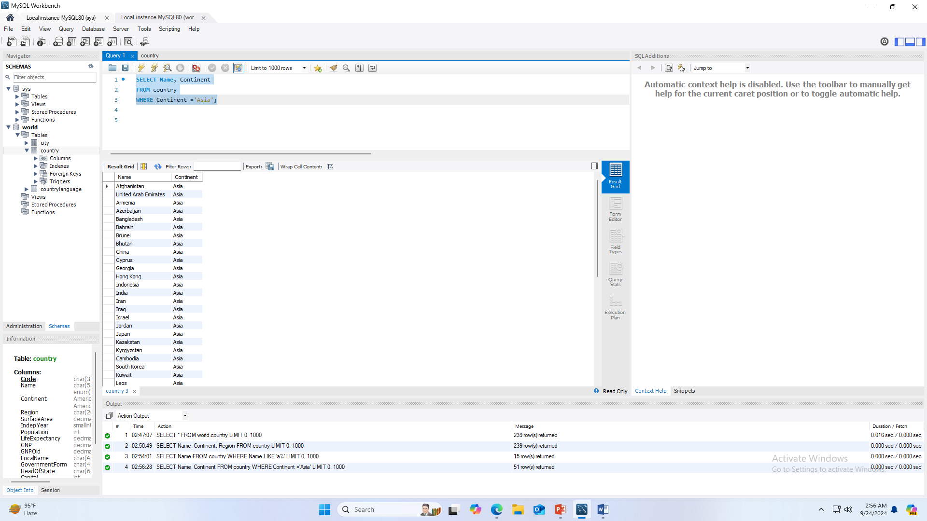

**Task 4: Retrieve all regions who have life expectancy greater than 80%.**

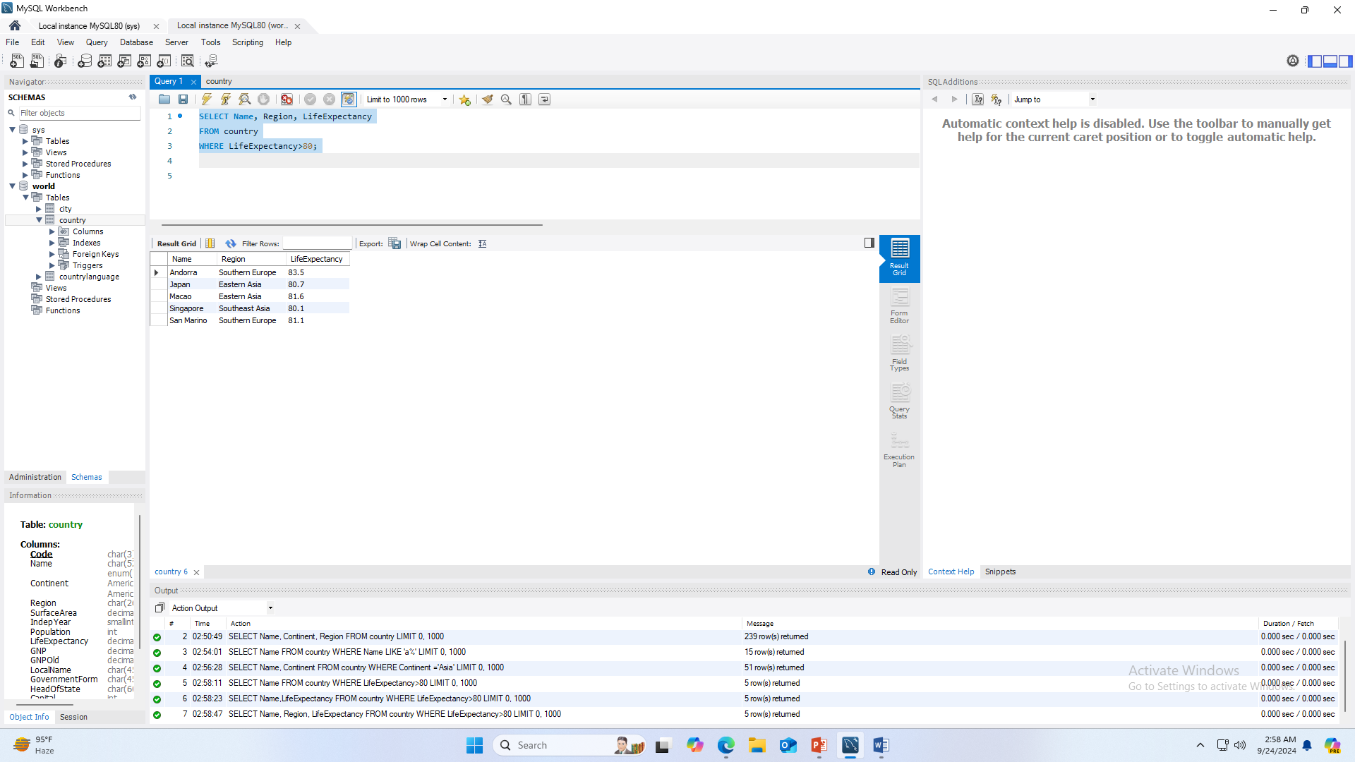

**Task 5: Find the distinct population in the city table.**

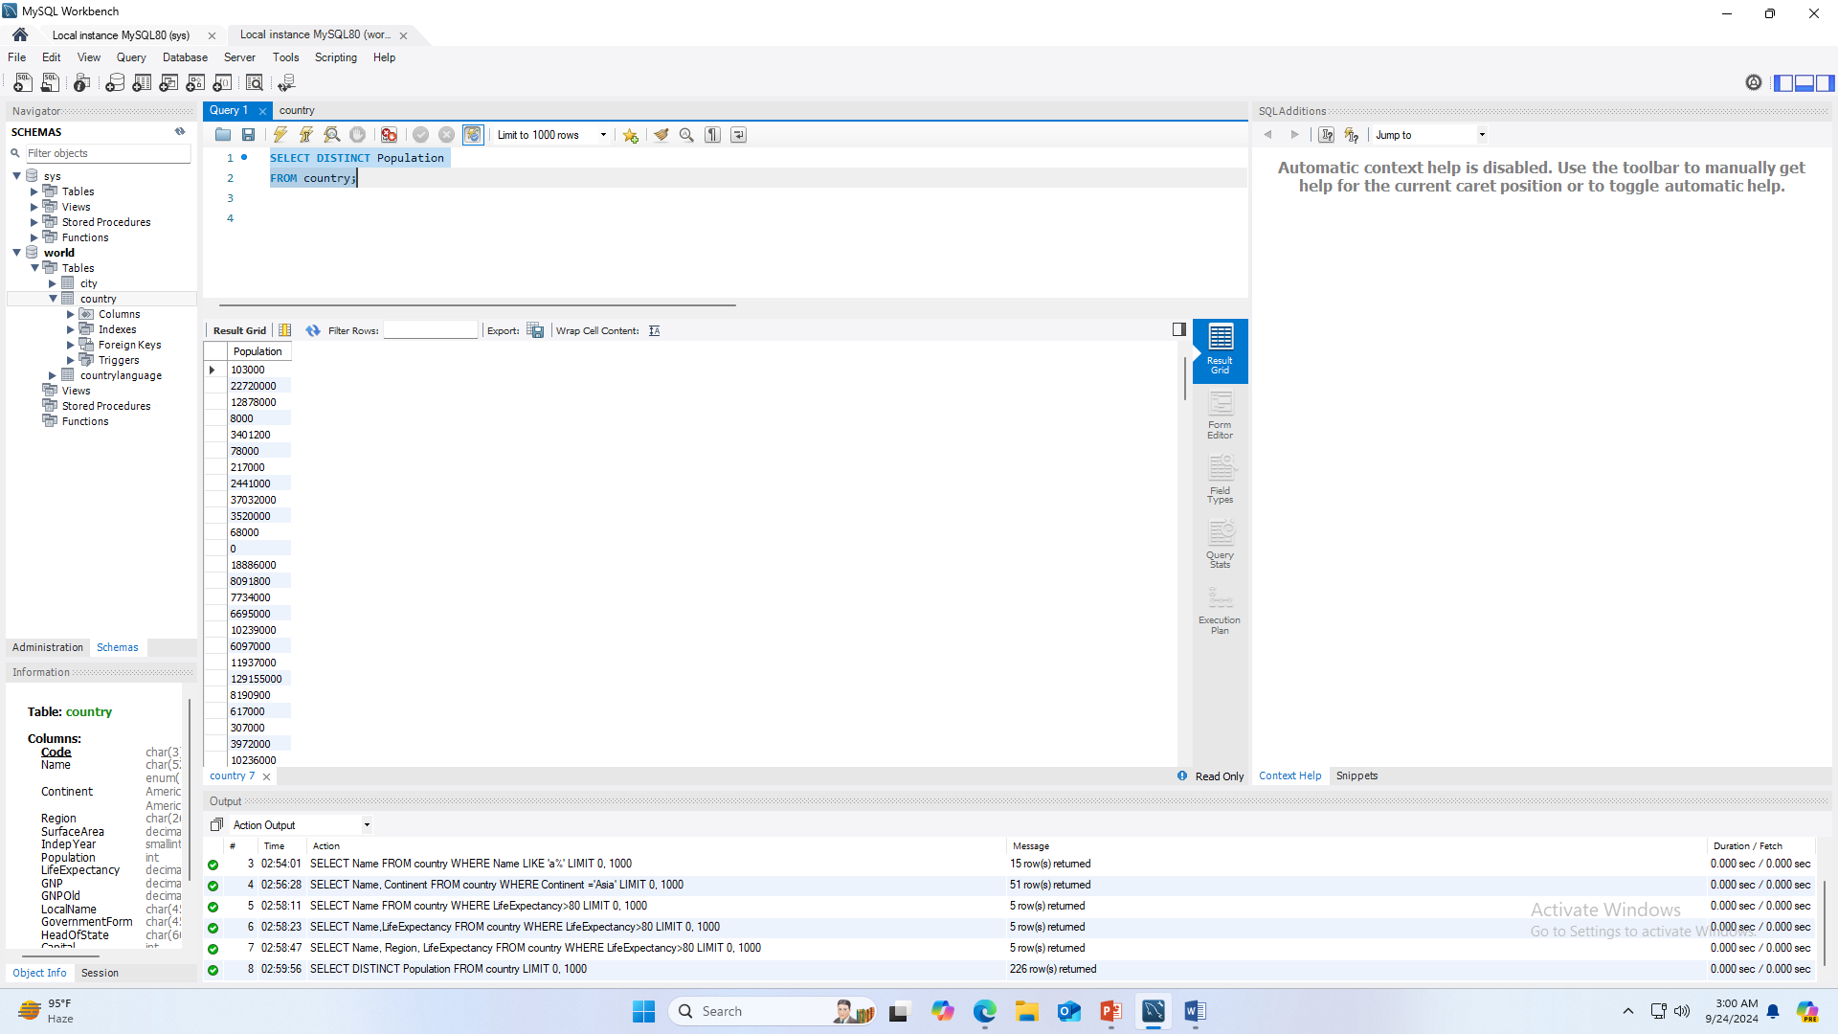

**Task 6: Retrieve first ten country languages.**

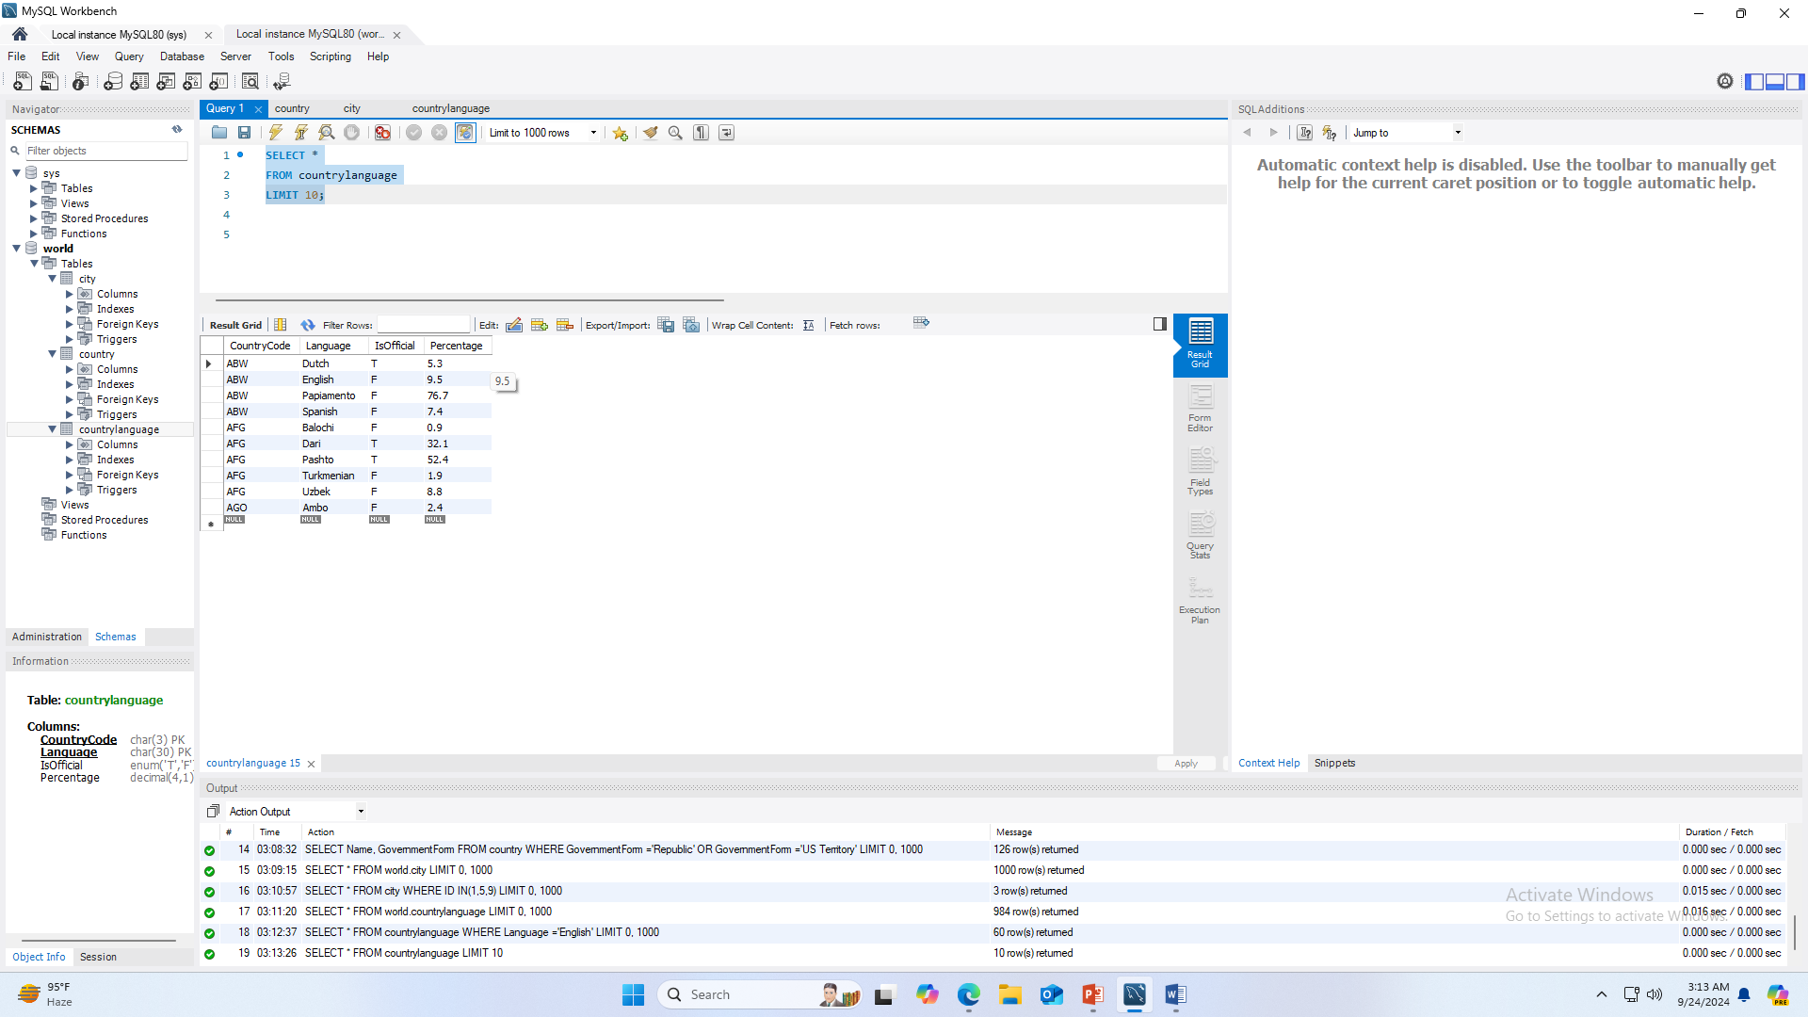

**Task 7: Display the countries that start with the alphabet a.**



**Task 8: Retrieve all the countries whose government is republic type and US Territory.**

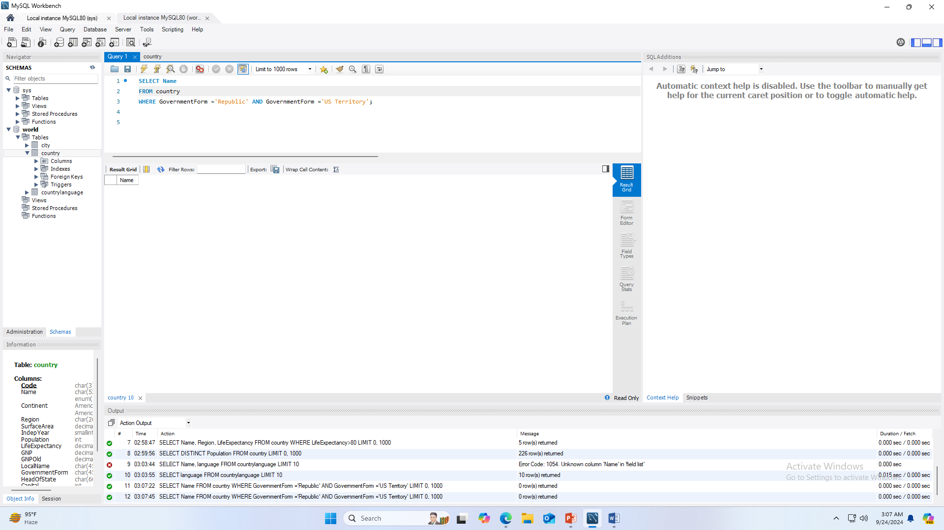

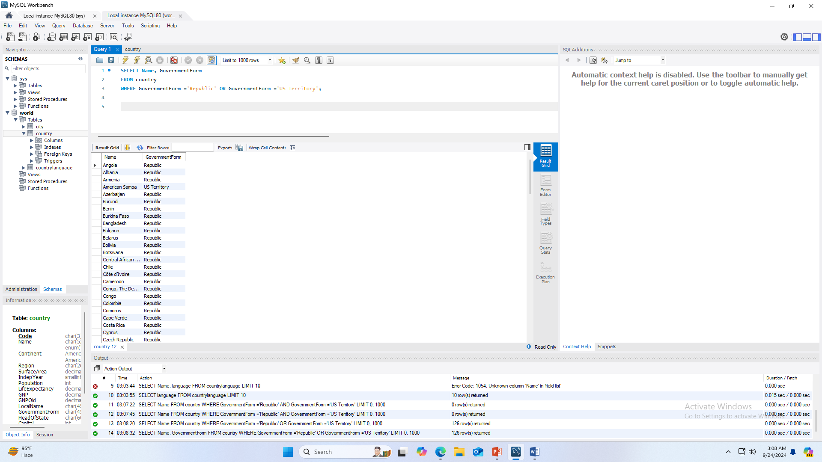

**Task 9: Retrieve the cities with IDs 1, 5, and 9.**

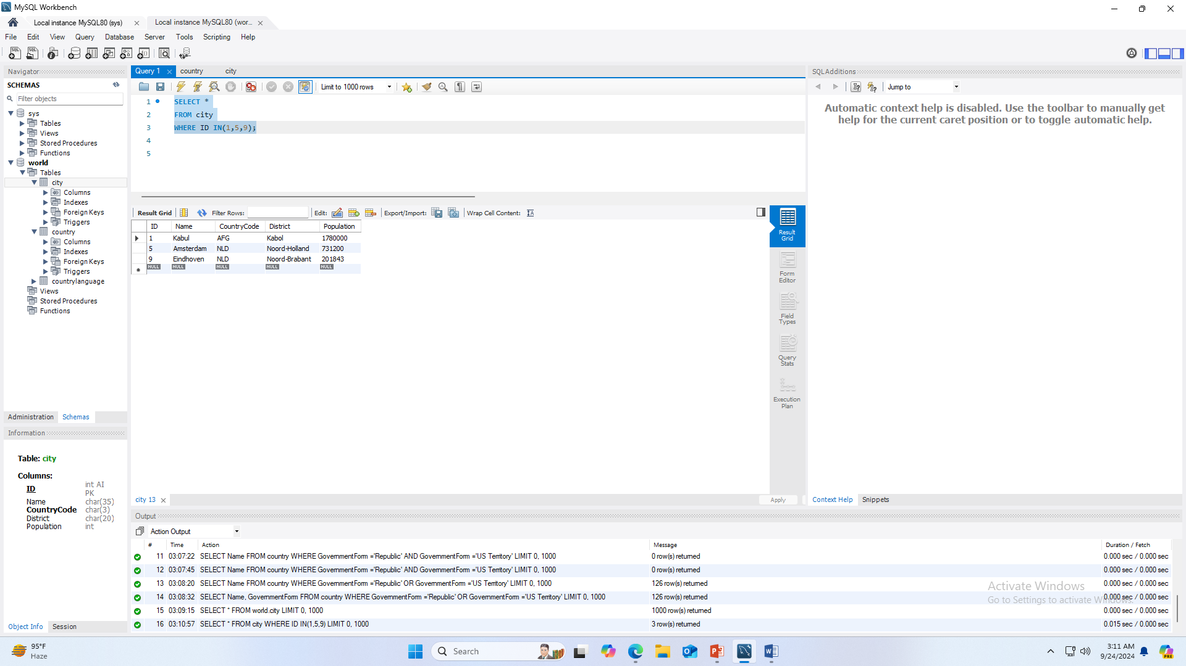

**Task 10: Retrieve all countries whose speaking language is English.**

